**HACKATHON CLOSING REPORT**

**SRNS:**

**PES1UG20CS067,Anuraag Mallinamaugu,**

**PES1UG20CS068,Anush Somasundaram,**

**PES1UG20CS109,Chetan Reddy Bandi,**

PES1UG20CS566><N V Rakesh Reddy>

1. Model chosen: Custom CNN Model

Custom CNN Model with 5 convolutional layers, using Relu as activation functions for the layers and sigmoid and softmax as loss functions implemented in pytorch.

For Transfer Learning model we implemented the VGG16 .

1. Justification:

It is a well diverse method for implementing the object detection and the classification so preferred to use it.

1. Parameters
   * Model Parameters:

Kernal size, Activation function, Fully Connected Layer, Stride, Padding, Number of filters.

* + Hyperparameters:

Batch Size, Number of epochs, Learning Rate, Dropout Rate.

1. Loss function:

In one of the convolutional layer, we used a sigmoid function and in the other layer we made use of softmax function.

1. Optimizer: Used Adam.
2. What Hyper parameters are tuned?

The hyper parameters that are tuned are Kernal Size, Number of filters, Learning rate, Batch Size.

1. Pictures of output results.
   * Epoch (graph)

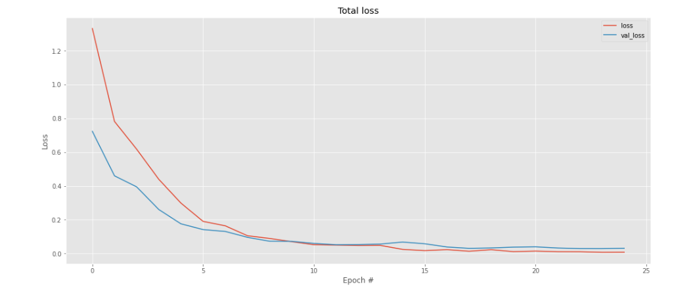

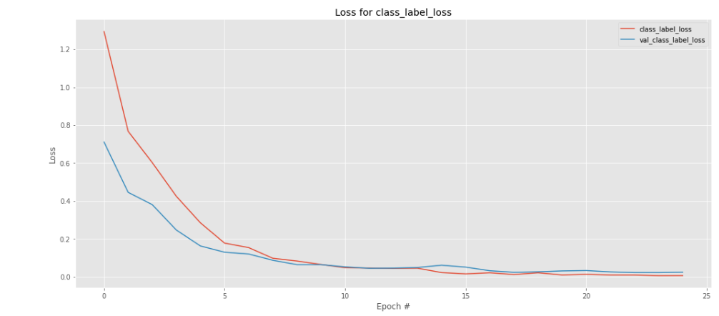

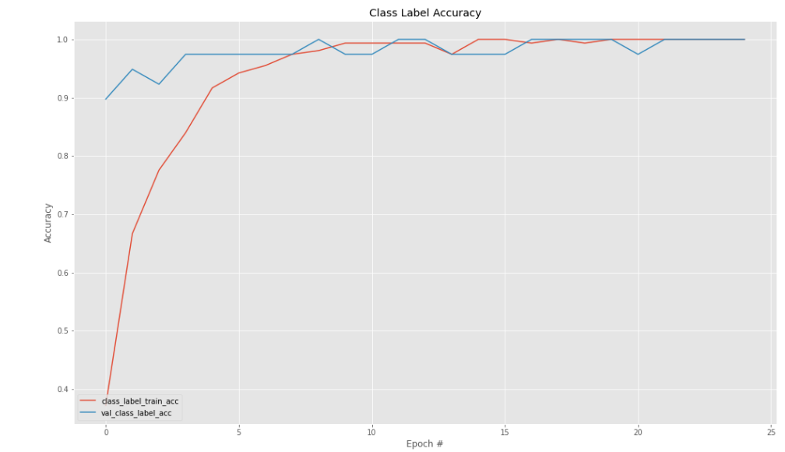

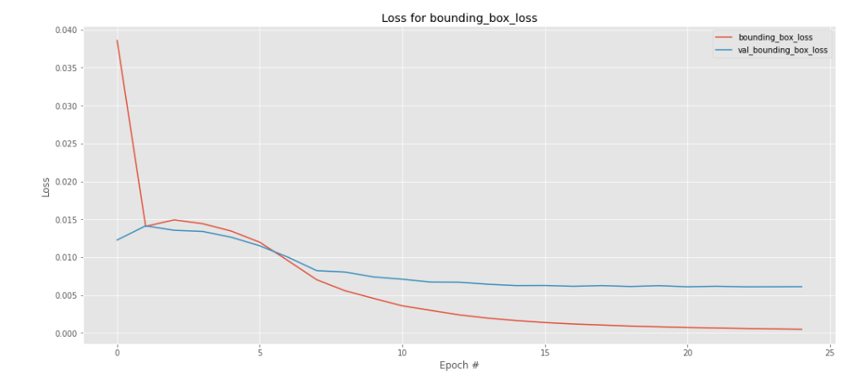

1. Learnings during the whole activity:

Initially we planed replicate yolov1 but after many attempts and many hours we didn’t get the results we wanted. We learned the yolo architecture from scratch. In this we learned many stages with 8 layers . The stages include Intersection over Union, Non max Suppression algorithm, dealing with the boundary boxes. Then we did the transfer learning model that plan and started working ourselves on the VGG16 model which proved to be quite good and able to train the model. Then started doing the CNN model with 5 layers where we got the results. So we got through topics of CNN,VGG16 architecture.

1. Related issues.

* Problem statement: The main issue was that we couldn’t use a pre-trained model like the yolo versions, TensorFlow, and the idea of building a model for object Detection from the scratch was quite hard.
* Dataset:

Extracting the images from the videos of the dataset was challenging. Also this segregating the data to the respective annotations was hard and took quite a lot of time.

* Compute resources: Resources were available but fitting the data into the resource was a challenge.
* Hosting Site (Kaggle): Kaggle was quite lagging and also on the first day couldn’t login it was giving 429 error.
* Internet facilities/Resources: The internet was decent. But it used to go off sometimes.

1. Comment with feedback

Overall Experience was quite good. We enjoyed working on a complex problem statement for 2 days and got a nice knowledge regarding Object Detection. All teachers were very supportive and helpful was fun doing it.

Regards,

V R Badri Prasad